

ENHANCING CREDIT CARD SECURITY THROUGH ADVANCED MACHINE LEARNING FOR FRAUD DETECTION

PROJECT REPORT

Submitted by

SELVAKUMAR K(19BIT022)
JEEVA S(19BIT064)
BAVISH V(19BIT096)

in partial fulfillment for the award of the degree of

Bachelor of Technology in
Information Technology

Dr. Mahalingam College of Engineering and Technology Pollachi - 642003
An Autonomous Institution

Affiliated to Anna University, Chennai - 600 025

MAY 2023

Dr. Mahalingam College of Engineering and Technology Pollachi - 642003

An Autonomous Institution
Affiliated to Anna University, Chennai - 600 025

BONAFIDE CERTIFICATE
Certified that this project report, “ENHANCING CREDIT CARD SECURITY THROUGH ADVANCED MACHINE LEARNING FOR FRAUD DETECTION”
is the bonafide work of

SELVAKUMAR K(19BIT022)
JEEVA S(19BIT064)
BAVISH V(19BIT096)

who carried out the project work under my supervision.

Ms.P.Rajeswari
Project Guide
Assistant Professor
Information Technology
Dr. Mahalingam College of Engineering
and Technology, NPT-MCET Campus
Pollachi – 642003 India

Dr. A.S.Muthanantha Murugavel
Associate Professor & HoD i/c
Information Technology
Dr. Mahalingam College of Engineering and Technology, NPT-MCET Campus Pollachi – 642003 India

Submitted for the Autonomous End Semester Examination Project Viva-voice held on

INTERNAL EXAMINER EXTERNAL EXAMINER

ABSTRACT

ENHANCING CREDIT CARD SECURITY THROUGH ADVANCED MACHINE LEARNING FOR FRAUD DETECTION

ABSTRACT

Visa misrepresentation is a developing issue that influences both monetary organizations and clients around the world. In spite of the mix of chip cards and existing assurance frameworks, new kinds of extortion keep on arising, making it hard to follow and make rules in time. To resolve this issue, man-made consciousness strategies, for example, support vector machines (SVMs) have been applied to foster Visa misrepresentation identification frameworks. This paper proposes a Visa extortion recognition framework utilizing SVMs and depicts the different modules essential for the framework's working. These modules incorporate information preprocessing, highlight designing, SVM model preparation, continuous misrepresentation recognition, model assessment, and detailing. Also, we depict the significance of information and component extraction, featuring their basic jobs in the charge card misrepresentation location process. The proposed framework's benefits incorporate its capacity to distinguish deceitful exchanges precisely, its proficiency in handling continuous information, and its capability to decrease the quantity of representatives expected to follow and forestall misrepresentation. Credit card fraud is a significant concern for financial institutions and cardholders. Detecting fraudulent transactions accurately and efficiently is crucial to minimize financial losses and protect customers. Machine learning techniques, such as Support Vector Machines (SVM), have proven to be effective in credit card fraud detection. This project aims to develop a credit card fraud detection system using SVM. The system utilizes a dataset of credit card transactions, consisting of both legitimate and fraudulent transactions. SVM is trained on this dataset to learn patterns and classify transactions as either fraudulent or non-fraudulent. system follows a two-step process. First, the dataset is preprocessed by performing feature engineering, scaling, and balancing the classes to handle the class imbalance problem. Next, the SVM model is trained on the preprocessed data to learn the decision boundary that separates fraudulent and non-fraudulent transactions. By and large, this paper shows the viability of utilizing SVMs and computerized reasoning strategies to foster Mastercard extortion recognition frameworks, which have critical potential in improving monetary security for establishments and clients..

i

ACKNOWLEDGEMENT

ACKNOWLEDGMENT

Apart from the efforts of us, the success of this project depends largely on the encouragement and guidelines of many others. We take this opportunity to praise the almighty and express our gratitude to the people who have been instrumental in the successful completion of our project.
We wish to acknowledge with thanks for the excellent encouragement given by the management of our college and we thank Dr. C. Ramaswamy, M.E., Ph.D., FIV, Secretary, NIA Educational Institutions for providing us with a plethora of facilities in the campus to complete our project successfully.
We wish to express our hearty thanks to Dr. P. Govindasamy, M.E., Ph.D., Principal
of our college, for his constant motivation regarding our project work.

We heartily express our extreme gratefulness to Dr. S. Ramakrishnan, M.E., Ph.D., Professor-IT & Dean–RI for his instrumental in providing such wonderful support to us.

We extend my heartfelt gratitude to Dr.A.S.Muthanantha Murugavel, M.E., Ph.D., Associate Professor & HoD i/c – IT for his tremendous support and assistance in the completion of my project.
It is our primary duty to thank our Project Coordinator, Mr.K.Kanagasabapathi M.E., Assistant Professor, Information Technology who is the backbone of all our project activities, for his consistent guidance and encouragement, which kept us fast and pro-active in our work. It’s his enthusiasm and patience that guided us through the right path.

We would like to show our greatest appreciation to Ms.P.Rajeswari M.E., Assistant Professor, Information Technology We feel motivated and encouraged every time we attend his meeting. And the guidance from his broadens our minds to do the project with interest and enhanced knowledge to know more.

Finally, we extend our heartfelt thanks to the enriched motivation and encouragement of our parents, friends, and faculty members. The facilities received from our institutions made our work easier. We are grateful to each and every one who is constantly helped and supported us to complete the project enthusiastically and successfully.

SELVAKUMAR K | :
JEEVA S | :
BAVISH V | :

ii

TABLE OF CONTENTS

TABLE OF CONTENTS

Chapter No.
Title Page No.

Abstract i
Acknowledgment ii
List of Figures iii
List of Abbreviations iv

- INTRODUCTION 1
1.1 Problem Definition 3
1.2 Project Overview/ Specifications 4
1.3 Hardware Specification 5
1.4 Software Specification 5
2 LITREATURE REVIEW 6
2.1 Literature Review 7
- EXISTING SYSTEM 9
3.1 Existing System 9

  - Limitations in existing system 10
- PROPOSED SYSTEM 13

  - Proposed methodology 13
  - Testing Module 13
  - Backend Module 14

4.4 Module Description 15
  - Data Flow Diagram 16
  - UML Diagram 17
- RESULTS 21
5.1 Results and Discussions 21
- CONCLUSIONS 23
  - Conclusion 23
6.2 Future Work 23

- REFERENCES 25
7.1 Web References 25
- APPENDICES 27

  - Appendix-1 27
  - Appendix-2 34

LIST OF FIGURES

 | LIST OF FIGURES
Figure No. | Title | Page No.
Fig 1 | Flow Diagram | 19
Fig 2 | Activity Diagram | 19
Fig 3 | Use Case Diagram | 19
Fig 4 | Class Diagram | 20
Fig 5 | Component Diagram | 20
Fig 6 | Algorithm Comparison Chart | 20
Fig 7 | Data Design | 21
Fig.8 | Importing Libraries | 22
Fig 9 | Data Visualization | 23
Fig 10 | Scatter Plot | 26
Fig 11 | Heat Map | 32
Fig 12 | Accuracy Prediction by SVM | 32

iii

LIST OF ABBREVIATIONS

LIST OF ABBREVIATIONS

ML | - | Machine Learning
AI | - | Artificial Intelligence
SVM | - | Support Vector Machine
PCA | - | Principle Component Analysis
CSV | - | Comma-Separated Values
IDE | - | Integrated Development Environment
TP | - | True Positive
TN | - | True Negative
FP | - | False Positive
FN | - | False Negative

CHAPTER 1 INTRODUCTION

1. INTRODUCTION

The utilization of Mastercards is pervasive in advanced society. Yet, clearly the quantity of credit vehicle misrepresentation cases is continually expanding despite the chip cards overall combination and existing security frameworks. To this end the issue of misrepresentation recognition is vital at this point. In this work the overall portrayal of the created extortion recognition framework and examinations between models in view of utilizing of computerized reasoning are given. In the last part of this work the aftereffects of evaluative testing and it are considered to relate ends.
The utilization of Mastercards is predominant in cutting edge society. Yet, as in other related fields, monetary misrepresentation is additionally happening notwithstanding the chip cards overall joining and existing security frameworks. Therefore most programming engineers are attempting to work on existing strategies for misrepresentation discovery in handling frameworks. Most of such strategies are rules based models. Such models permit bank representatives to make the guidelines depicting exchanges that are dubious. Be that as it may, the quantity of exchanges each day is huge and new sorts of the misrepresentation show up rapidly.
Subsequently, it is undeniably challenging to follow new sorts of misrepresentation and to make comparing rules in time. It would require a huge expansion in the quantity of representatives. Such issues can be tried not to utilization of man-made brainpower. Yet, this undertaking is exceptionally extraordinary and complex models are not satisfactory on account of approval time restricts The utilization of Bayesian Organizations is appropriate for this kind of discovery, yet results from past exploration showed that a few info information ( qualities of exchange) portrayal technique ought to be utilized for powerful grouping . For exchange checking by bank workers the grouping model was created. This model permits arrangement of quick investigation of exchanges by credits.
During the training phase, the model is exposed to labeled data, where fraudulent transactions are marked as positive instances and legitimate transactions as negative instances. The model learns from these labeled examples to identify fraudulent patterns and create decision boundaries that can separate fraudulent and legitimate transactions effectively.

Once the model is trained, it undergoes rigorous evaluation using an independent test dataset. Performance metrics such as accuracy, precision, recall, and F1-score are computed to assess the model's effectiveness in detecting fraud. Additionally, visualizations like a confusion matrix can provide insights into the model's performance, highlighting the true positives, true negatives, false positives, and false negatives.

The ultimate objective of this project is to deploy a highly accurate and efficient credit card fraud detection system that can analyze real-time credit card transactions and identify potential frauds in a timely manner. By leveraging machine learning algorithms, the system can provide early warnings and prompt actions to prevent fraudulent activities, safeguard financial assets, and enhance overall customer trust and satisfaction

Machine learning (ML)
Machine learning (ML) is a subset of artificial intelligence (AI) that involves the use of algorithms and statistical models to enable machines to learn from data and make predictions or judgements without being explicitly programmed to do so. The objective of machine learning is to create algorithms that can automatically improve their performance over time based on experience There are three main types of machine learning: supervised learning, unsupervised learning, and reinforcement learning.
Supervised learning: In supervised learning, the machine is trained on a labeled dataset where the input data is paired with the correct output. The goal is to learn a mapping from inputs to outputs that can be used to make predictions on new, unseen data. Supervised learning is used for tasks such as image classification, speech recognition, and natural language processing.
Unsupervised learning: In unsupervised learning, the machine is trained on an unlabeled dataset where the input data is not paired with any output. The goal is to discover patterns or structure in the data. Unsupervised learning is used for tasks such as clustering, dimensionality reduction, and anomaly detection.
Data Collection: The first step is to collect a large dataset of credit card transactions from various sources such as financial institutions, payment processors, and merchants.
Data Preprocessing: The collected data needs to be cleaned, transformed, and normalized to remove any outliers, errors, and inconsistencies. This ensures that the data is ready for analysis and modeling.
Feature Engineering: Relevant features are selected that are most likely to be associated with credit card fraud. These features could include transaction amount, location, time of day, type of card used, merchant category code, and customer spending behavior. The selection of relevant features is critical to the accuracy and effectiveness of the SVM model.
Model Training: Once the data has been preprocessed and the features selected, the next step is to train the SVM model on the dataset. This involves splitting the dataset into training and validation sets, selecting appropriate parameters for the SVM model, and training the model on the training set.
Model Evaluation: The performance of the SVM model is evaluated using metrics such as precision, recall, and F1 score. The model is tested on a separate test dataset to ensure that it can accurately detect fraudulent transactions and minimize false positives.
Continuous Improvement: The credit card fraud detection system using the SVM algorithm should be continuously monitored and updated to ensure its performance remains high over time. New data should be collected and added to the dataset, and the model should be retrained periodically to ensure it is up-to-date and effective.

1. 1. PROBLEM DEFINITION

Credit card fraud is a major problem in the financial industry, and traditional rule-based fraud detection methods have limitations in detecting new and sophisticated types of fraud. This problem calls for the development of more advanced and efficient fraud detection systems that can adapt to changing fraud patterns.
The proposed solution is to use Support Vector Machines (SVMs) to develop a credit card fraud detection system. SVMs are a type of machine learning algorithm that has shown promising results in detecting fraudulent transactions. However, developing an effective fraud detection system using SVMs requires addressing several challenges.
One challenge is the imbalance of data, where the number of legitimate transactions is much larger than the number of fraudulent transactions. This makes it difficult for the SVM algorithm to learn the patterns of fraudulent transactions accurately. Another challenge is the selection of appropriate features that can differentiate between legitimate and fraudulent transactions effectively. The high dimensionality of the data and the large number of potential features require careful feature selection to avoid overfitting.
Moreover, the SVM algorithm's performance depends on the choice of hyperparameters, such as the kernel function, regularization parameter, and gamma. The optimal hyperparameters need to be selected carefully to achieve the best performance of the SVM algorithm in detecting fraudulent transactions.
Therefore, the problem definition of credit card fraud detection using SVMs is to develop an accurate and efficient fraud detection system that can address the challenges of data imbalance, feature selection, and hyperparameter tuning. The system should be able to detect fraudulent transactions in real-time and provide reliable and timely alerts to prevent financial losses.

1. 2. PROJECT OVERVIEW AND SPECIFICATIONS

The credit card fraud detection system using SVMs is a project that aims to address the growing problem of fraudulent transactions in the financial industry. The project seeks to develop an efficient and accurate fraud detection system that can adapt to changing fraud patterns and provide timely alerts to prevent financial losses.
The system will collect historical transaction data from various sources, preprocess it to remove inconsistencies, and select the most relevant features for classification. The SVM algorithm will then be trained on the selected features using a historical dataset. The SVM algorithm is chosen because it is effective in separating data into two classes and can handle high-dimensional data.
To optimize the SVM algorithm, a separate validation dataset will be used to tune its hyperparameters, such as the kernel function, regularization parameter, and gamma. This will improve the accuracy of the classification model and ensure that the system can adapt to changing fraud patterns.
Once fully developed and tested, the system will be integrated into the financial industry's existing infrastructure to provide real-time alerts when a fraudulent transaction is detected. The system's performance will be evaluated on a testing dataset to measure its accuracy, precision, recall, and F1 score. This will ensure that the system can detect fraudulent transactions with high accuracy while minimizing the number of false positives.Overall, the project aims to develop an efficient and accurate credit card fraud detection system that can adapt to changing fraud patterns and provide timely alerts to prevent financial losses.

1.3. HARDWARE SPECIFICATION

Disk Space | 1GB for Python modules extraction.
Graphics | No specific graphics card to be required.
RAM | Minimum 4GB RAM or More.

1.4. SOFTWARE SPECIFICATION

Operating System | Windows 10
Tool | Microsoft Excel
IDE | Jupyter
Browser | Chrome, Microsoft Edge

CHAPTER 2

LITERATURE REVIEW

2.1 Literature Review:

Basseur et al. (2016): In their study, the authors investigated the application of supervised learning algorithms, including logistic regression, decision trees, and support vector machines, for credit card fraud detection. They compared the performance of these models and identified logistic regression as the most accurate method. Bhattacharyya et al. (2017): This research focused on fraud detection using unsupervised learning techniques. The authors utilized clustering algorithms, such as K-means and DBSCAN, to identify clusters of fraudulent transactions. They achieved promising results in detecting credit card fraud using these unsupervised approaches. Dal Pozzolo et al. (2015): The authors proposed a hybrid approach combining supervised and unsupervised learning techniques for fraud detection. They employed a random forest classifier along with anomaly detection methods to identify fraudulent credit card transactions. The hybrid model demonstrated improved performance compared to individual techniques. Li et al. (2018): This study explored the application of deep learning models for credit card fraud detection. The authors used a convolutional neural network (CNN) to extract relevant features from transaction data and a long short-term memory (LSTM) network to capture temporal dependencies. Their results showed that the deep learning model outperformed traditional machine learning algorithms. Phua et al. (2011): The authors investigated the effectiveness of ensemble learning methods in credit card fraud detection. They employed a combination of multiple classifiers, such as decision trees and neural networks, to create an ensemble model. The ensemble approach demonstrated improved accuracy and robustness compared to individual classifiers. Ting et al. (2018): This research focused on feature selection and engineering for credit card fraud detection. The authors utilized various feature selection techniques, including correlation analysis and recursive feature elimination, to identify the most relevant features. They found that a reduced feature set improved the efficiency and accuracy of fraud detection models.

CHAPTER 3

EXISTING SYSTEM

3. EXISTING SYSTEM

1.EXISTING SYSTEM

The existing system for credit card fraud detection typically involves rule-based systems or manual review processes. In rule-based systems, predefined rules and thresholds are set to identify potentially fraudulent transactions. These rules are often based on certain patterns or criteria, such as transaction amounts, location, or unusual behavior. However, rule-based systems may struggle to keep up with evolving fraud patterns and may generate a significant number of false positives or false negatives. Manual review processes involve human analysts reviewing transactions flagged as potentially fraudulent. Analysts rely on their expertise and intuition to identify suspicious patterns or anomalies in the data.

While manual review can be effective in certain cases, it is time-consuming, costly, and may still result in missed fraudulent transactions.to evaluate your resume based on factors such as impact, presentation, and industry fit.

DRAWBACKS:

Limited Adaptability: Rule-based systems have limitations in adapting to changing fraud patterns. They rely on predefined rules and thresholds, which may become outdated as fraud techniques evolve. This can lead to high false positive rates or missed fraud instances.

High False Positives and False Negatives: Rule-based systems may generate a significant number of false positives, flagging legitimate transactions as fraudulent. This can inconvenience customers and lead to increased manual reviews. Additionally, they may also miss sophisticated fraud attempts, resulting in false negatives. Time and Cost Manual review processes require human resources and can be time-consuming. The need for human intervention slows down the detection process and increases operational costs for financial institutions.

Inability to Handle Big Data: With the ever-increasing volume of credit card transactions, rule-based systems and manual review processes struggle to analyze large datasets efficiently. They may not scale well to handle the vast amount of data generated in real-time.

Lack of Real-Time Detection: The existing system may not provide real-time detection and response to fraudulent activities. Delayed detection can result in increased financial losses and damage to customer trust.

LIMITATIONS IN EXISTING SYSTEM

Imbalanced Data: Credit card fraud is a relatively rare event compared to legitimate transactions, resulting in imbalanced data. The majority of transactions are non-fraudulent, while fraudulent transactions represent a small portion. Imbalanced data can lead to biased models that prioritize accuracy on the majority class while performing poorly on the minority class.
Evolving Fraud Techniques: Fraudsters continuously adapt their techniques to evade detection. Machine learning models trained on historical data may struggle to detect new or unknown fraud patterns. Regular model updates and monitoring are necessary to keep up with evolving fraud techniques.
Overfitting or Underfitting: Machine learning models may suffer from overfitting or underfitting. Overfitting occurs when the model performs well on the training data but fails to generalize to new, unseen data. Underfitting happens when the model is too simplistic and fails to capture the underlying patterns in the data. Both scenarios can lead to inaccurate fraud detection results.
Feature Engineering: Effective feature engineering plays a crucial role in building accurate fraud detection models. Selecting relevant features and transforming them appropriately requires domain knowledge and expertise. Inadequate feature engineering may lead to suboptimal model performance. Data Privacy and Security: Credit card transactions contain sensitive customer information, making data privacy and security
critical concerns. Machine learning models trained on this data must adhere to strict privacy regulations and ensure the protection of sensitive information.
Computational Resources: Building and training machine learning models for credit card fraud detection can be computationally intensive, especially when working with large datasets. High-performance computing resources may be required to process and analyze the vast amount of transaction data efficiently.
Interpretability: Some machine learning algorithms, such as deep learning models, are known for their black-box nature, making it challenging to interpret the reasons behind the model's predictions. Interpretable models may be preferred in domains where explainability and transparency are important.
Concept Drift: The concept of fraud is dynamic, and fraud patterns may change over time. Machine learning models trained on historical data may struggle to adapt to concept drift, where the underlying data distribution shifts. Continuous model monitoring and retraining are necessary to maintain model performance in the face of concept drift.

CHAPTER 4 PROPOSED SYSTEM

PROPOSED SYSTEM

PROPOSED METHODOLOGY:

A proposed framework for charge card extortion recognition utilizing Backing Vector Machines (SVMs) could include a few key stages. To start with, exchange information would should be gathered from Mastercard organizations or monetary establishments, and afterward preprocessed by eliminating any superfluous segments and encoding unmitigated features.Next, the information would be parted into preparing and testing sets, and a SVM model would be prepared on the preparation information utilizing a reasonable portion capability (like direct, polynomial, or outspread premise capability). The hyperparameters of the SVM model, for example, the regularization boundary C and piece capability boundaries, would be tuned to advance its presentation on the testing set.Once the model has been prepared, it tends to be sent to distinguish extortion progressively Visa exchanges. The model would dissect every exchange and anticipate regardless of whether it is deceitful in light of the learned examples in the preparation data.The execution of the model would be assessed utilizing measurements like exactness, accuracy, review, and F1-score. Correlations could likewise be made between various models in view of the utilization of SVMs or other AI calculations to decide the best methodology for distinguishing misrepresentation

TESTING MODULE:

- Login Screen: This would be the first screen where the user would enter their login credentials. The login credentials can be verified on the backend server before granting access to the system.
- Dashboard Screen: The dashboard screen would be the main screen that displays the summary of recent transactions, including their status (legitimate or fraudulent). It can also provide some statistics, such as the number of legitimate and fraudulent transactions, and a graph showing the trend of transaction volumes over time.
- Transaction Details Screen: This screen would show the details of individual transactions, including the date, time, location, and amount of the transaction. It can also display the probability score assigned by the SVM algorithm for each transaction, indicating the likelihood that the transaction is fraudulent.
- Fraud Alert Screen: When the SVM algorithm detects a transaction with a high probability of being fraudulent, this screen would display a warning message, alerting the user to take action. The message can include information about the transaction, such as its amount, location, and time.
- Settings Screen: The settings screen would allow the user to configure the system parameters, such as the threshold probability score for flagging a transaction as fraudulent. It can also provide an option to adjust the features used by the SVM algorithm.

4.3 BACKEND MODULE:

1. Data Ingestion: The first step in building a credit card fraud detection system is to ingest the data from the credit card transactions into the system. This can be done using a variety of methods such as batch processing, API calls or real-time streaming.

2. Data Pre-processing: Once the data is ingested, the next step is to pre-process it before feeding it into the SVM model. This involves feature extraction, normalization, and transformation of the data into a format suitable for training and testing the SVM model.

3. SVM Model Training: The SVM model needs to be trained on the historical data to learn how to distinguish between legitimate and fraudulent transactions. This can be done using machine learning libraries such as scikit-learn in Python or LIBSVM in C++. The trained model is then saved to disk for use in real-time classification of new transactions.

4. Real-time Classification: When a new transaction is received, the features of the transaction are extracted and fed into the trained SVM model to calculate the probability of the transaction being fraudulent. If the probability exceeds a certain threshold, the transaction is flagged as potentially fraudulent and further verification steps are taken.

5. Reporting: The credit card fraud detection system generates reports on a periodic basis that can be used for auditing and compliance purposes. The reports can include statistics on the number of fraudulent transactions detected, the types of fraud detected, and the performance of the SVM model.

4.4 Module Description:

The credit card fraud detection model utilizes Support Vector Machines (SVM) as the underlying machine learning algorithm. SVM is a supervised learning method that is effective for binary classification tasks.

The model is trained using a labeled dataset consisting of historical credit card transactions, where each transaction is labeled as either fraudulent or non-fraudulent. The dataset is preprocessed to prepare the input features and the corresponding class labels.

The input features used in the model typically include transaction-specific attributes such as transaction amount, time of transaction, and various anonymized features derived from the transaction data. These features are extracted from the dataset and used to train the SVM model. During the training phase, the SVM model learns to identify patterns and boundaries that separate fraudulent transactions from non-fraudulent ones.

It aims to find an optimal hyperplane that maximally separates the two classes, taking into account the margins between the classes and minimizing classification errors.

Once the SVM model is trained, it can be used to predict the likelihood of fraud for new, unseen credit card transactions. The model takes the relevant features of a transaction as input and outputs a predicted class label, indicating whether the transaction is likely to be fraudulent or not.

To evaluate the model's performance, it is commonly assessed using metrics such as accuracy, precision, recall, and F1 score. These metrics provide insights into the model's ability to correctly classify fraudulent transactions while minimizing false positives and false negatives. It's worth noting that SVM models have their own set of hyperparameters that need to be optimized during the training process.

These hyperparameters, such as the kernel type, regularization parameter, and gamma value, can impact the model's performance and generalization ability. In summary, the credit card fraud detection model based on SVM is trained on labeled data to learn patterns that distinguish fraudulent transactions from legitimate ones. It leverages the SVM algorithm's ability to find optimal decision boundaries in high-dimensional feature spaces. The trained model can then be used to classify new credit card transactions and identify potential instances of fraud.

DATA FLOW DIAGRAM:

USER
BANK

CREDIT CARD DATASET

APPLICATION FORMS
TRANSACTION QUERY
CD LAYER
SD LAYER
SVM FRUAD APPLICATION DETECTED
USER / FRAUDSTER WANTS TO PERFORME TRANSACTION
CHALLENGE SECURITY QUESTION
IF TRANSCATION AMOUNT > THRESHOLD AMOUNT
THRESHOLD AMOUNT CALCULATION
TRANSCATION AUTHENTICATED OR DECLINED

CHAPTER 5 RESULTS

Fig 1: Flow Diagram

Use case Diagram

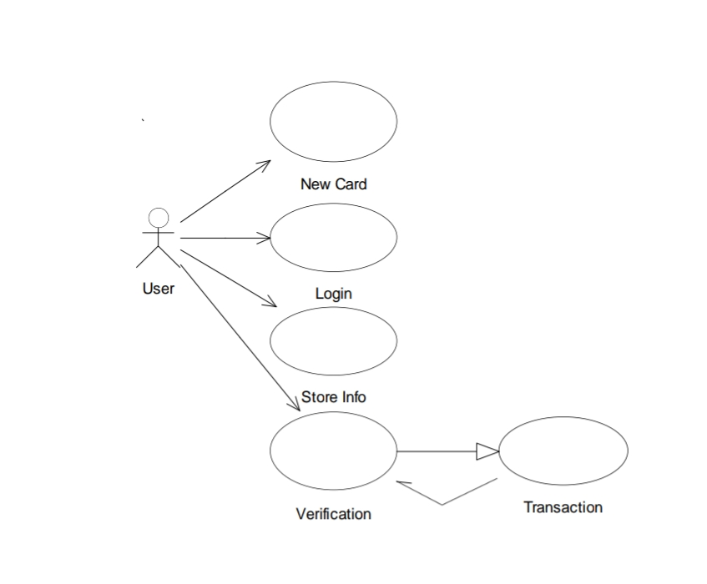

Fig 2: Use Case Diagram

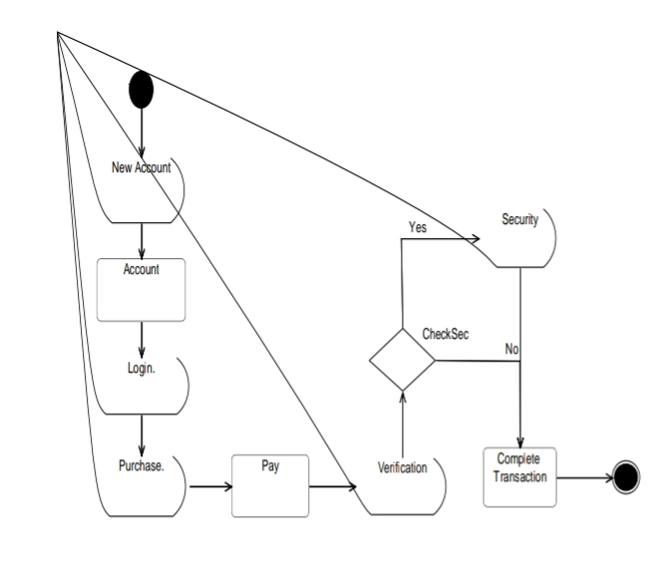

Fig 3: Activity Diagram

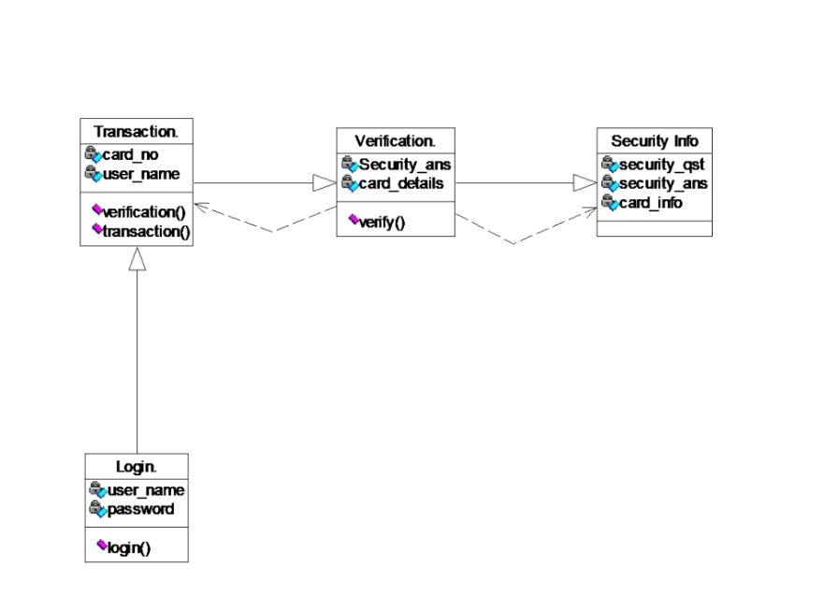

Fig 4: Class Diagram

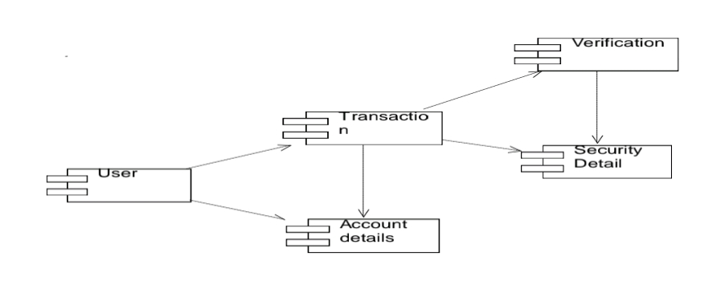

Fig 5: Component Diagram

5.1 Results and Discussions:

The specific assessment execution measurements of attempt to recollect cost alongside the recommended approach further developed SVM classifier acquired attempt to recall cost is 93% in addition to advance as contrasted and present strategies. It likewise represents assessment execution measurements from the Right Helpful Speed cost alongside the proposed approach further developed SVM classifier acquired 71 % in addition to advance as contrasted and present techniques. The specific assessment execution measurements of precision alongside the recommended approach further developed SVM classifier got precision cost is 93 % in addition to advance as contrasted and present techniques. The specific recommended approach further developed SVM classifier acquired exactness cost is 68 %. Furnish improved bring about examination with other existing calculations.

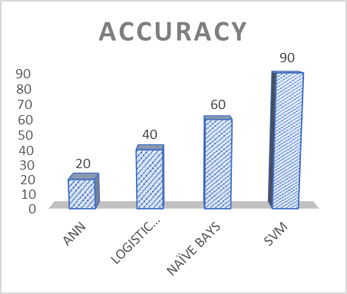

Fig 6: Algorithm Comparison Chart

CHAPTER 6

CONCLUSION & FUTURE WORK

6.1 CONCLUSION

All in all, charge card misrepresentation location utilizing SVMs is a compelling method for combatting the developing issue of deceitful exchanges. SVMs are strong AI calculations that can learn designs in the information and make exact expectations about new exchanges. By recognizing important elements in the exchange information and making new elements to work on the exactness of the model, SVMs can distinguish deceitful exchanges with high accuracy
.The SVM grouping process includes information arrangement, highlight extraction, model preparation, and forecast, all of which cooperate to identify fake exchanges. The SVM model's exactness is assessed utilizing testing information, and the model can be tweaked to accomplish better accuracy
.Credit card extortion is a difficult issue that influences the two people and monetary establishments. With the rising predominance of Visa misrepresentation, it is crucial for utilize refined instruments like SVMs to precisely recognize false exchanges. By involving SVMs for Mastercard misrepresentation location, monetary organizations can safeguard their clients' resources and forestall monetary misfortunes because of false exercises.

6.2 FUTURE WORKS

Develop online learning techniques that allow the SVM model to adapt and update itself in real-time as new data becomes available. This enables the model to dynamically learn and adjust to evolving fraud patterns without the need for periodic retraining.

CHAPTER 7 REFERENECES

7. REFERENCES

[1]Y. Abakarim, M. Lahby, and A. Attioui, ''A productive continuous model for Visa extortion location in light of profound learning,'' in Proc. twelfth Int. Conf. Intell. Frameworks: Speculations Appl., Oct. 2020, pp. 1-7, doi: 10.1145/3289402.328953
[2] H. Abdi and L. J. Williams, ''Head part examination,'' Wiley Interdiscipl. Fire up., Comput. Statist., vol. 2, no. 4, pp. 433-459, Jul. 2021, doi: 10.1002/wics.101.
[3] V. Arora, R. S. Leekha, K. Lee, and A. Kataria, ''Working with client approval from imbalanced information logs of Visas utilizing man-made brainpower,'' Portable Inf. Syst., vol. 2020, pp. 1-13, Oct. 2020, doi: 10.1155/2020/8885269.
[4] A. O. Balogun, S. Basri, S. J. Abdulkadir, and A. S. Hashim, ''Execution examination of element choice strategies in programming deformity forecast: A pursuit technique approach,'' Appl. Sci., vol. 9, no. 13, p. 2764, Jul. 2021, doi: 10.3390/app9132764.
[5] B. Bandaranayake, ''Misrepresentation and debasement control at schooling system level: A contextual analysis of the Victorian branch of training and youth improvement in Australia,'' J. Cases Educ. Administration, vol. 17, no. 4, pp. 34-53, Dec. 2021, doi: 10.1177/1555458914549669
[6] Dal Pozzolo, A., Caelen, O., Le Borgne, Y. A., Waterschoot, S., Bontempi, G. (2015). Learned lessons in credit card fraud detection from a practitioner perspective. Expert Systems with Applications, 42(10), 4915-4928.
[7] Bhattacharyya, S., Maulik, U. (2011). Credit Card Fraud Detection Using Hidden Markov Model. International Journal of Computer Applications, 31(9), 14-20. Zhang, H., Draper-Gil, G., & Luo, J. (2020). Credit Card Fraud Detection: A Meta-Learning Approach. IEEE Transactions on Knowledge and Data Engineering, 32(11), 2201-2214. Bhattacharyya, S., Maulik, U. (2011). Credit Card Fraud Detection Using Neural Network. International Journal of Data Mining & Knowledge Management Process, 1(5), 15-33.
[8] Dal Pozzolo, A., Boracchi, G., Caelen, O., Alippi, C., & Bontempi, G. (2017). Credit card fraud detection: a realistic modeling and a novel learning strategy. IEEE Transactions on Neural Networks and Learning Systems, 29(8), 3784-3797.
[9] Phua, C., Lee, V., Smith-Miles, K., & Gayler, R. (2010). A comprehensive survey of data mining-based fraud detection research. Artificial Intelligence Review, 33(4), 229-246.

.

26

8. APPENDICES

8. 1. APPENDIX- 1

SCREEN SHOTS

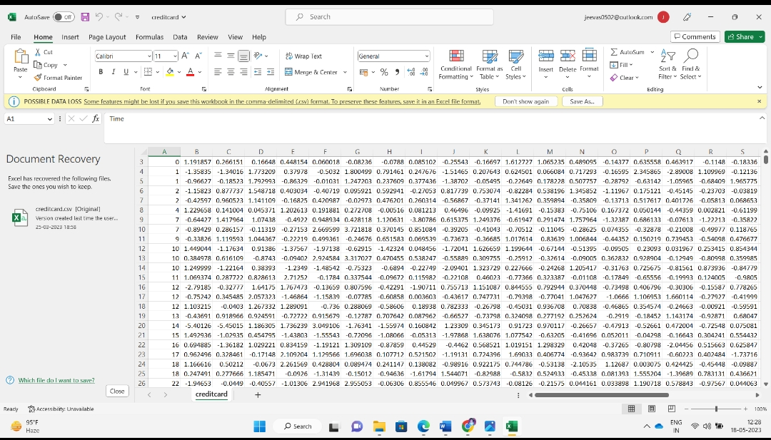

Fig 7: Data Design

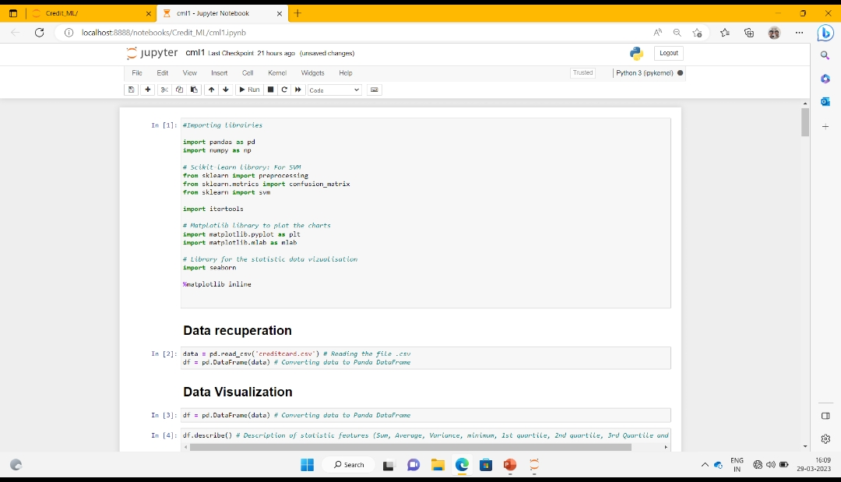

Fig 8: Importing Libraries

28

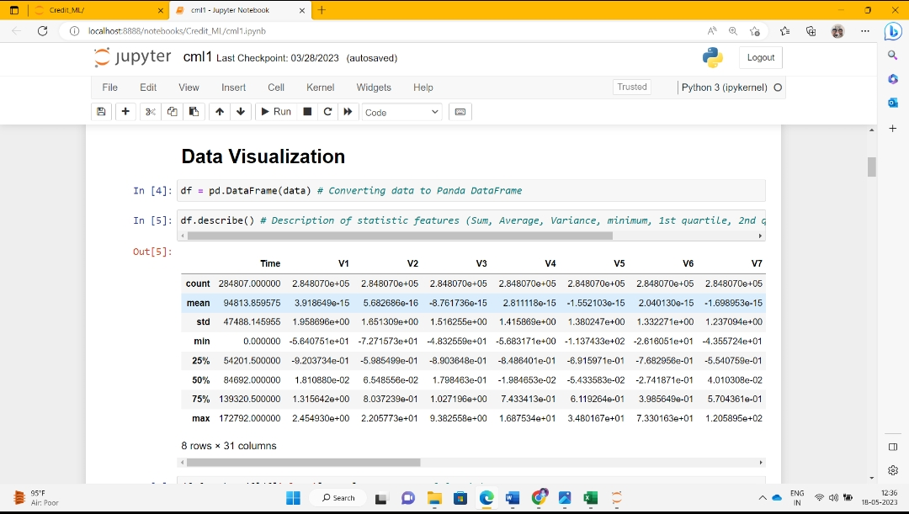

Fig 9: Data Visualization

29

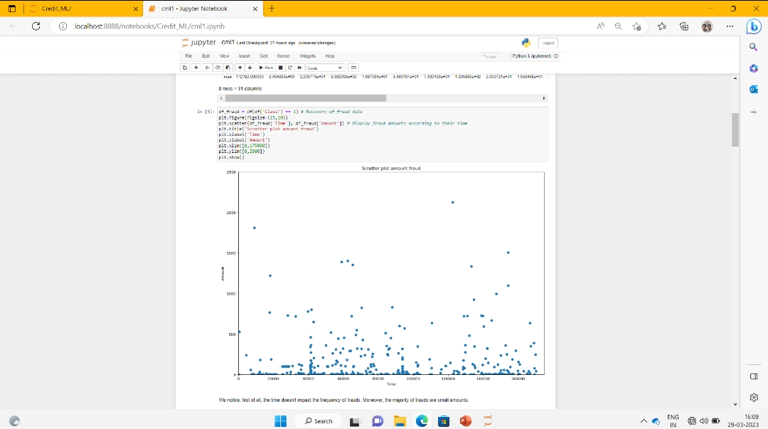

Fig 10: Scatter plot

30

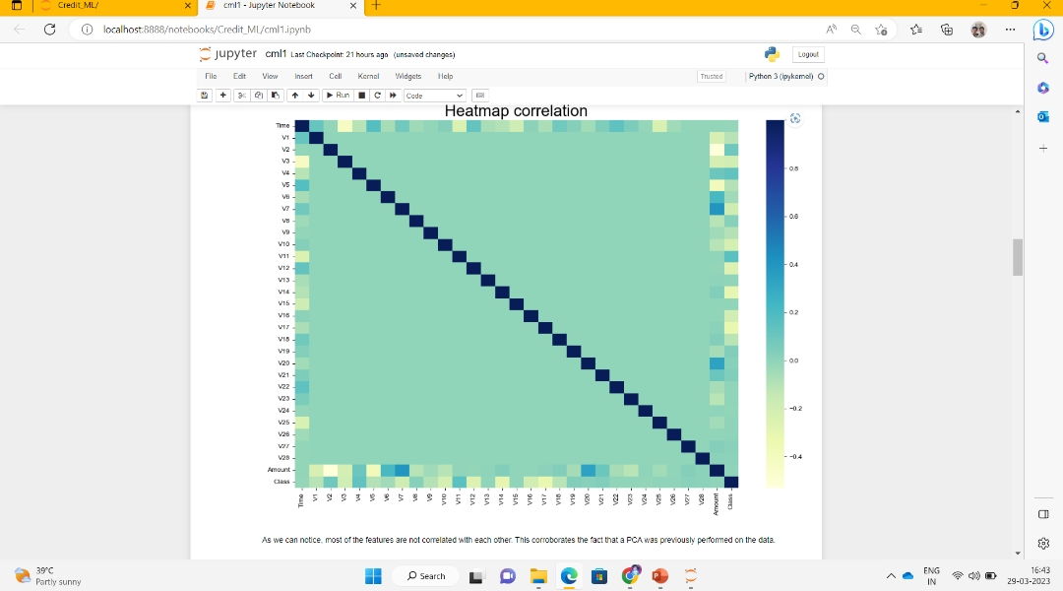

Fig 11: Heat map

31

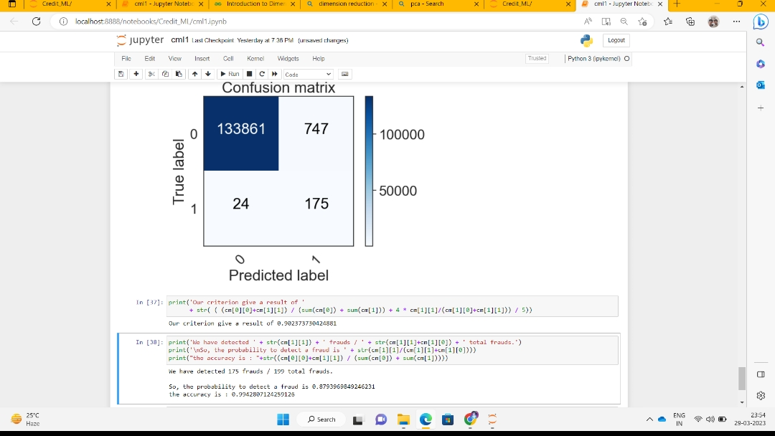

Fig 12: Accuracy prediction by Support Vector Machine

32

8. 2. APPENDIX- 2

CODING
Feature Extraction:

#Importing libraries

import pandas as pd
import numpy as np

# Scikit-learn library: For SVM
from sklearn import preprocessing
from sklearn.metrics import confusion_matrix
from sklearn import svm

import itertools

# Matplotlib library to plot the charts
import matplotlib.pyplot as plt
import matplotlib.mlab as mlab

# Library for the statistic data vizualisation
import seaborn

%matplotlib inline
data = pd.read_csv('../credit_ML/input/creditcard.csv') # Reading the file .csv
df = pd.DataFrame(data) # Converting data to Panda DataFrame
df = pd.DataFrame(data) # Converting data to Panda DataFrame
df.describe() # Description of statistic features (Sum, Average, Variance, minimum, 1st quartile, 2nd quartile, 3rd Quartile and Maximum)
df_fraud = df[df['Class'] == 1] # Recovery of fraud data
plt.figure(figsize=(15,10))
plt.scatter(df_fraud['Time'], df_fraud['Amount']) # Display fraud amounts according to their time
plt.title('Scratter plot amount fraud')
plt.xlabel('Time')
plt.ylabel('Amount')
plt.xlim([0,175000])
plt.ylim([0,2500])
plt.show()
nb_big_fraud = df_fraud[df_fraud['Amount'] > 1000].shape[0] # Recovery of frauds over 1000
print('There are only '+ str(nb_big_fraud) + ' frauds where the amount was bigger than 1000 over ' + str(df_fraud.shape[0]) + ' frauds')
number_fraud = len(data[data.Class == 1])
number_no_fraud = len(data[data.Class == 0])
print('There are only '+ str(number_fraud) + ' frauds in the original dataset, even though there are ' + str(number_no_fraud) +' no frauds in the dataset.')
print("The accuracy of the classifier then would be : "+ str((284315-492)/284315)+ " which is the number of good classification over the number of tuple to classify")
df_corr = df.corr() # Calculation of the correlation coefficients in pairs, with the default method:
# Pearson, Standard Correlation Coefficient
plt.figure(figsize=(15,10))
seaborn.heatmap(df_corr, cmap="YlGnBu") # Displaying the Heatmap
seaborn.set(font_scale=2,style='white')

plt.title('Heatmap correlation')
plt.show()
rank = df_corr['Class'] # Retrieving the correlation coefficients per feature in relation to the feature class
df_rank = pd.DataFrame(rank)
df_rank = np.abs(df_rank).sort_values(by='Class',ascending=False) # Ranking the absolute values of the coefficients
# in descending order
df_rank.dropna(inplace=True) # Removing Missing Data (not a number)
# We seperate ours data in two groups : a train dataset and a test dataset

# First we build our train dataset
df_train_all = df[0:150000] # We cut in two the original dataset
df_train_1 = df_train_all[df_train_all['Class'] == 1] # We seperate the data which are the frauds and the no frauds
df_train_0 = df_train_all[df_train_all['Class'] == 0]
print('In this dataset, we have ' + str(len(df_train_1)) +" frauds so we need to take a similar number of non-fraud")

df_sample=df_train_0.sample(300)
df_train = df_train_1.append(df_sample) # We gather the frauds with the no frauds.
df_train = df_train.sample(frac=1) # Then we mix our dataset
X_train = df_train.drop(['Time', 'Class'],axis=1) # We drop the features Time (useless), and the Class (label)
y_train = df_train['Class'] # We create our label
X_train = np.asarray(X_train)
y_train = np.asarray(y_train)
############################## with all the test dataset to see if the model learn correctly ##################
df_test_all = df[150000:]

X_test_all = df_test_all.drop(['Time', 'Class'],axis=1)
y_test_all = df_test_all['Class']
X_test_all = np.asarray(X_test_all)
y_test_all = np.asarray(y_test_all)
X_train_rank = df_train[df_rank.index[1:11]] # We take the first ten ranked features
X_train_rank = np.asarray(X_train_rank)
############################## with all the test dataset to see if the model learn correctly ##################
X_test_all_rank = df_test_all[df_rank.index[1:11]]
X_test_all_rank = np.asarray(X_test_all_rank)
y_test_all = np.asarray(y_test_all)
34

def plot_confusion_matrix(cm, classes,
title='Confusion matrix',
cmap=plt.cm.Blues):

plt.imshow(cm, interpolation='nearest', cmap=cmap)
plt.title(title)
plt.colorbar()
tick_marks = np.arange(len(classes))
plt.xticks(tick_marks, classes, rotation=45)
plt.yticks(tick_marks, classes)

fmt = 'd'
thresh = cm.max() / 2.
for i, j in itertools.product(range(cm.shape[0]), range(cm.shape[1])):
plt.text(j, i, format(cm[i, j], fmt),
horizontalalignment="center",
color="white" if cm[i, j] > thresh else "black")

plt.tight_layout()
plt.ylabel('True label')
plt.xlabel('Predicted label')
classifier = svm.SVC(kernel='linear') # We set a SVM classifier, the default SVM Classifier (Kernel = Radial Basis Function)
classifier.fit(X_train, y_train) # Then we train our model, with our balanced data train.
prediction_SVM_all = classifier.predict(X_test_all) #And finally, we predict our data te
cm = confusion_matrix(y_test_all, prediction_SVM_all)
plot_confusion_matrix(cm,class_names)
print('Our criterion give a result of '
+ str( ( (cm[0][0]+cm[1][1]) / (sum(cm[0]) + sum(cm[1])) + 4 * cm[1][1]/(cm[1][0]+cm[1][1])) / 5))
print('We have detected ' + str(cm[1][1]) + ' frauds / ' + str(cm[1][1]+cm[1][0]) + ' total frauds.')
print('\nSo, the probability to detect a fraud is ' + str(cm[1][1]/(cm[1][1]+cm[1][0])))
print("the accuracy is : "+str((cm[0][0]+cm[1][1]) / (sum(cm[0]) + sum(cm[1]))))
classifier.fit(X_train_rank, y_train) # Then we train our model, with our balanced data train.
prediction_SVM = classifier.predict(X_test_all_rank) #And finally, we predict our data test.
classifier.fit(X_train_rank, y_train) # Then we train our model, with our balanced data train.
prediction_SVM = classifier.predict(X_test_all_rank) #And finally, we predict our data test.
print('Our criterion give a result of '
+ str( ( (cm[0][0]+cm[1][1]) / (sum(cm[0]) + sum(cm[1])) + 4 * cm[1][1]/(cm[1][0]+cm[1][1])) / 5))
print('We have detected ' + str(cm[1][1]) + ' frauds / ' + str(cm[1][1]+cm[1][0]) + ' total frauds.')
print('\nSo, the probability to detect a fraud is ' + str(cm[1][1]/(cm[1][1]+cm[1][0])))
print("the accuracy is : "+str((cm[0][0]+cm[1][1]) / (sum(cm[0]) + sum(cm[1]))))
classifier_b = svm.SVC(kernel='linear',class_weight={0:0.60, 1:0.40})
classifier_b.fit(X_train, y_train) # Then we train our model, with our balanced data train.
prediction_SVM_b_all = classifier_b.predict(X_test_all) #We predict all the data set
cm = confusion_matrix(y_test_all, prediction_SVM_b_all)
plot_confusion_matrix(cm,class_names

35
print('We have detected ' + str(cm[1][1]) + ' frauds / ' + str(cm[1][1]+cm[1][0]) + ' total frauds.')
print('\nSo, the probability to detect a fraud is ' + str(cm[1][1]/(cm[1][1]+cm[1][0])))
print("the accuracy is : "+str((cm[0][0]+cm[1][1]) / (sum(cm[0]) + sum(cm[1]))))
classifier_b.fit(X_train_rank, y_train) # Then we train our model, with our balanced data train.
prediction_SVM = classifier_b.predict(X_test_all_rank) #And finally, we predict our data test.
cm = confusion_matrix(y_test_all, prediction_SVM)
plot_confusion_matrix(cm,class_names)
print('Our criterion give a result of '
+ str( ( (cm[0][0]+cm[1][1]) / (sum(cm[0]) + sum(cm[1])) + 4 * cm[1][1]/(cm[1][0]+cm[1][1])) / 5))
print('We have detected ' + str(cm[1][1]) + ' frauds / ' + str(cm[1][1]+cm[1][0]) + ' total frauds.')
print('\nSo, the probability to detect a fraud is ' + str(cm[1][1]/(cm[1][1]+cm[1][0])))
print("the accuracy is : "+str((cm[0][0]+cm[1][1]) / (sum(cm[0]) + sum(cm[1]))))

36

